Homework 2

Integration of Ontologies: FrameNet, SUMO, WordNet, DBPedia.

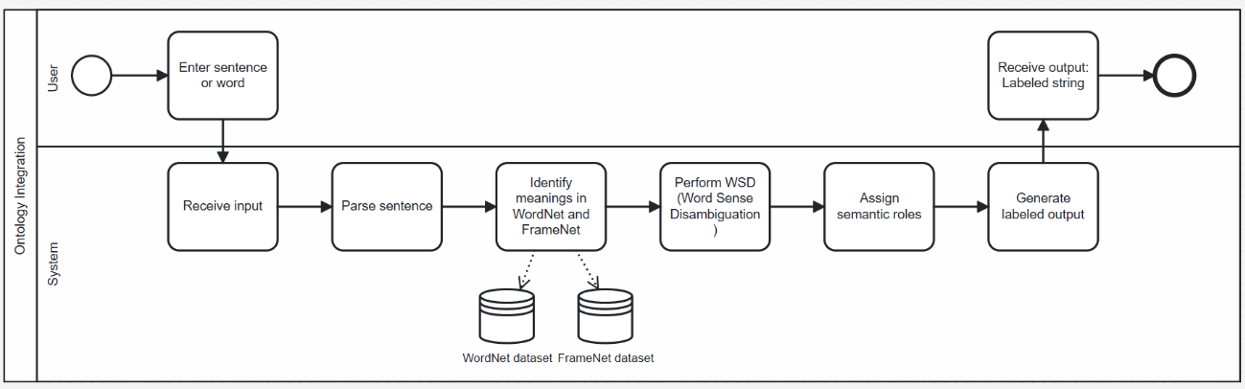

Goal:
To develop an end-to-end pipeline that integrates multiple ontologies to improve semantic alignment and interoperability in NLP systems.

Overview:
The project proposes a system that automatically aligns and integrates semantic knowledge across ontologies. It focuses on mapping linguistic frames to lexical concepts and linking them to upper ontologies.

Examples of (X,y) in the context of my thesis:

X (Input): Ontological or linguistic features describing a concept/frame/synset.
Y (Output): The mapped or aligned concept in another ontology.

X (Input) | y (Output)
User’s text | Semantically labeled text
FrameNet frame “Eating” | WordNet synset eat.v.01 (“take in solid food”)
FrameNet frame “Travel” | WordNet synset travel.v.01 (“change location”)
FrameNet frame “Communication” | WordNet synset communicate.v.01 (“transmit information”)
FrameNet frame “Learning” | WordNet synset learn.v.01 (“gain knowledge or skill”)
FrameNet frame “Buying” | WordNet synset purchase.v.01 (“obtain by paying money”)

This table shows examples of how FrameNet frames can be linked to WordNet synsets based on their meanings. Each FrameNet frame represents a general semantic situation or event, while the WordNet synset provides a specific lexical meaning of a word related to that situation.

COLAB 1 - human-face-image-data.ipynb

This Colab script is a complete pipeline for processing emotional video data - it downloads videos, extracts audio and text, captures image frames, and finally saves all results to Google Drive.

Video → Audio (extracts the sound from each video)
Audio → Text (transcribes speech into written text using Whisper)
Video → Image (takes one frame from the middle of each video)
Text + Images → ZIP files

COLAB 2 – GOOGLE_GENAI

Colab 2 is a pipeline that processes images (like frames extracted from videos) and generates text descriptions for them using AI. It automates the process of turning visual content into textual data that can be used for analysis, labeling, or further machine learning tasks.

How It Works:

- It reads a ZIP of images from Google Drive.
- Extracts the images into Colab.
- Uses Gemma AI to analyze each image and generate a text description.
- Saves each description as a .txt file.
- Zips all text files into a new ZIP and uploads it back to Google Drive.

In simple terms, it turns images into written descriptions automatically using AI.

